**Task 1**

**1.Task Description**:

Create a component that uses React Context for global state management. This component will manage a user’s login status and display their information if they are logged in.

**2.Task Output Screenshot**

Hover effect on login

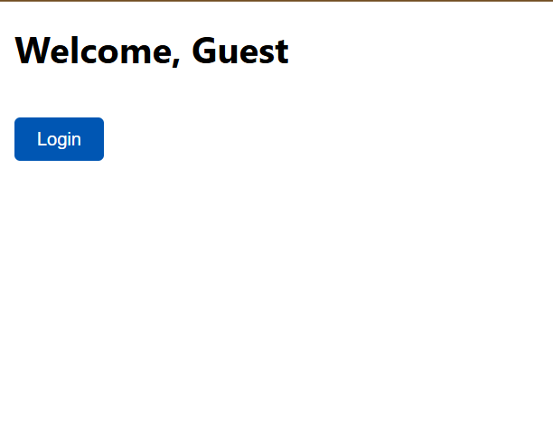



**3.Widget/Algorithm Used In Task**

**a. React Context API:** Used to provide a centralized state accessible across multiple components in the application, avoiding the need for prop drilling.

**b. useContext Hook:** Used to access the context values in the component that displays the user's information.

**c. State Management:** The context holds the user's login status and details, which can be updated globally through context.